5321 Homework 3

Summer 2020

Question Weighting:

Question 1- 5 - 20 % cr/edit each - total 100% credit

Use the EBP approach for each problem.

1. Develop CFG (reduced) and Cyclomatic complexity.
2. Develop basis path set.
3. Determine significance on each variable.
4. Add tests for missing Boundary Values not tested, including extreme range values - extreme range values for EACH variable that has a boundary condition in the code.
5. For basis path use the all true path as the first test case.

Submittal items, **for each problem** ***submit*** the following and number them accordingly

1. Code description
   1. For problem 1 and 2 use a decision table. Use slide 61 of M03 as a guide for the decision table format.
   2. For problems 3 and 4 use a logical expression
   3. For problem 5 draw a graph (can be drawn by hand and scanned in). Make sure axes are labeled with values at each whole number
2. CFG (reduced) - can be hand drawn and scanned
3. Cyclomatic Complexity (indicate on the graph)
4. Test case table with basis paths (put these in the "Basis Path" column. Where tests are addition to basis path set use a "-" in the basis path column. Make sure all true is the first BP.
5. Code coverage achieved
6. Test cases support or refute description?

Assume:

1. a significance of 1 Cent on financial calculations
2. Assume 0.1 on all doubles, unless otherwise specified.
3. Use Excel's default of rounding to the significance. For financial display $0.00 and doubles 0.0 except as otherwise indicated - this will implicitly round to the significance.

Proper application of the CFG to the basis path

1. **Start at the upper left and work toward the lower right of the CFG flipping decisions from upper left toward lower right. Make sure to put nodes at subsequent levels on the CFG. See slides 41-44 of M09**

1) Use basis path testing to develop the test cases for the following code. Use the line (statement) numbers below in your CFG. AGL ranges from 0.0 to 10,000.0 feet both inclusive with 0.1 feet of significance.

4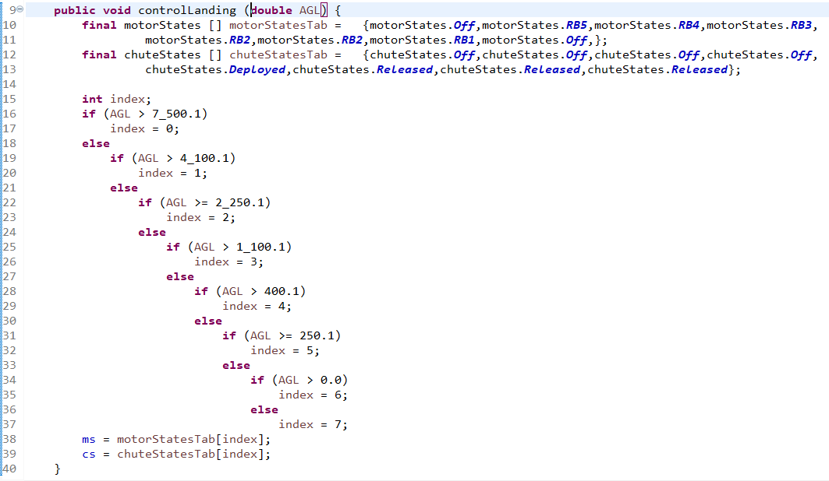

Test case table format:



2) Use basis path testing to develop the test cases for the following code. Use the line (statement) numbers below in your CFG. Assume batteryLevel ranges from 0.0 to 1,000.0 watts both inclusive.

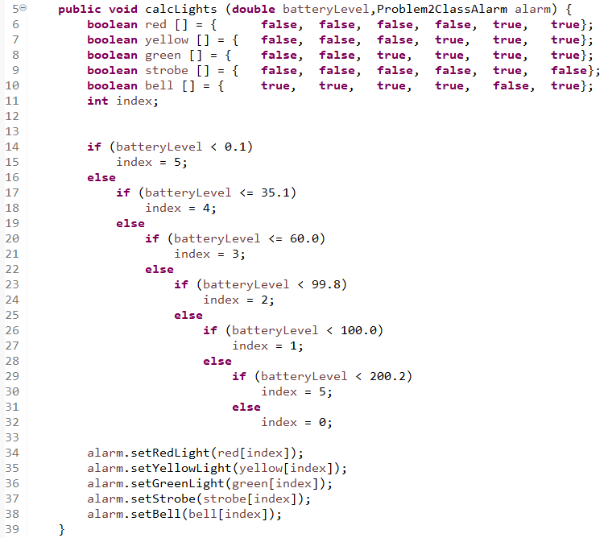

Test case table format:



3) Use basis path testing to develop the test cases for the following code. Use the line (statement) numbers below in your CFG. Assume that total ranges from $0.00 to $20,000.00 and memberPoints from 0 to 9,999 all inclusive.

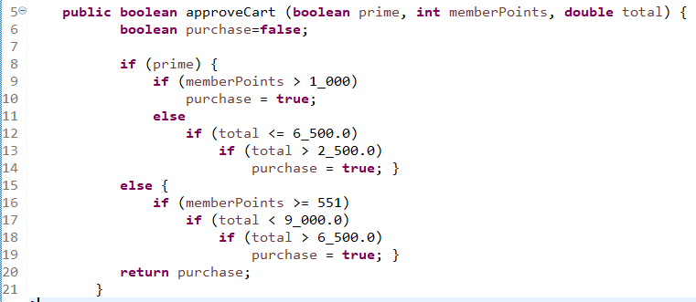

Test case table format



Mentally transform statements 9-14 and 16-19 into a multiple condition decision statement as described in slides 41-52 of M09 and show the MCDC test cases for this logical expression in the test case table.

4) Use basis path testing to develop the test cases for the following code. Use the line (statement) numbers below in your CFG. Assume that temperature ranges from 0 to 500 degrees F, pressure from 0.0 to 10,000 psi all inclusive and both with a significance of 0.1

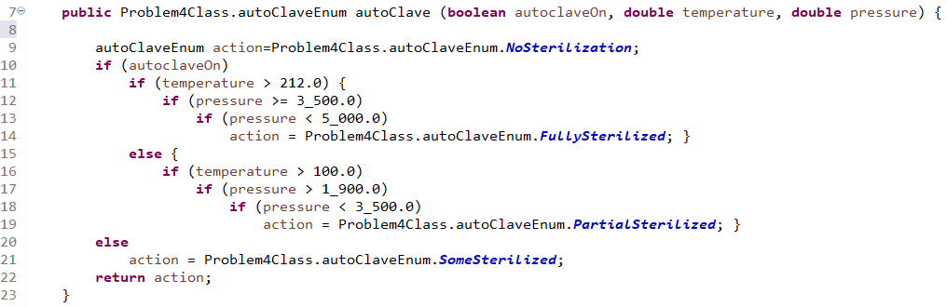

Test case table format:



Mentally transform statements 10-13 and 15-18 into multiple condition decision statement as described in slides 41-52 of M09 and show the MCDC test cases for this logical expression in the test case table.

5) Use basis path testing to develop the test cases for the following code. Use the line (statement) numbers below in your CFG. Assume that x ranges from -2.00 to 10.00 both inclusive. Assume both y and y are significant to 0.01 (use Excel's answer without truncation which means it will round to the 0.01).

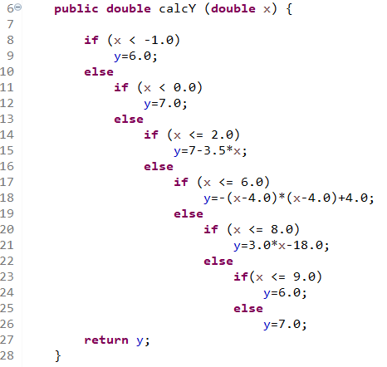

Add tests as follows:

1. For each linear region, in the middle of the ECP.
2. For each parabolic - at the max/min and mid-range (mid-range of x) on one side of the max/min. (2 tests total).

**Submit the graph with your solution. Develop your tests using the graph. You may hand draw the graph and scan BUT IT MUST BE GRADEABLE. You must label the axes and show values across each axis at each whole number.**

**dr**

Test Case table format

